# Product Teardown – Cisco NSO

# (Network Service Orchestrator)

## **Target Audience**

* + Telecommunication Service Providers (Telco’s):

This specific persona usually operates with multi-vender complex architectures which perfectly aligns with NSO USP. ISP’s will get attracted due to NSO efficiency to reduce configuration/service provisioning cost and reduce the Time-to-Market for various end customer services like Enterprise broadband, VPN, MPLS, Firewall Configuration etc. Company e.g. – Airtel, Vodafone, du, Etisalat, STC, AT&T

* + Large Enterprise with Multivendor Networks

Enterprises managing large IT and networking infrastructures require vendor-agnostic solutions to simplify operations. E.g. General Electric, JP Motors

* + Managed Service Providers (MSPs)

MSPs serve multiple customers and need tools to streamline network provisioning, reduce manual errors, and deliver services faster. E.g. Orange, TCS

* + Government and public sector organisations

Governments often have mission-critical networks with stringent performance and security requirements. E.g. U.S. Department of Defence (DoD)

## **Big Picture**

Cisco was struggling with its legacy business of just selling networking hardware. NSO helped the company Shifting from one-time hardware sales to **subscription-based licensing** and acting as a stepping stone for the enablement of innovation in the field of using AI/ML in network automation.

Telco’s are the mainstream market and with NSO they could capture big market share and became the prime service orchestrator among Telco industry. NSO also helped to benchmark NaaS (Network as a service) and forget the legacy style of network service configurations.

Enabling pay-as-you-grow models for service providers, aligned well with Cisco’s push toward recurring revenue streams from their software and services.

## **Proof of Concept (POC) at Sandbox**

Go and reserve your sandbox <https://devnetsandbox.cisco.com/DevNet> to experience the minimalistic Proof of Concept (POC) on Cisco own LAB Infrastructure and start successfully start building a Network of Automation for your potential use cases.

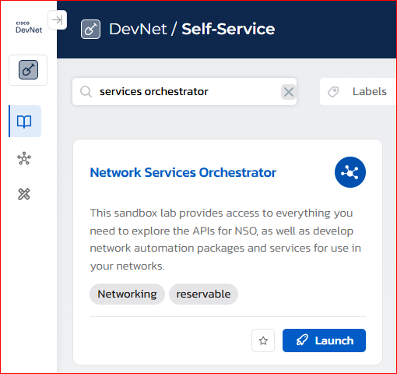

### **1.1 Benefit to Users:**

This is an excellent step in product strategy to provide public sandbox which helps users to:

* Explore the existing UI and CLI
* Experiment building basic hypothetical use cases
* Validate the platform core features

### **1.2 Benefit to Business:**

* Gather user feedback on the product’s user experience.
* Extend user feedback to Product Team to Iterate and improve on the UI/UX.
* Early Adoption of platform by making the product approachable and usable before the deal.
* Creating the buzz for the product to support the product pricing and subscription Licensing.

## **Product Description**

Cisco NSO is a model-driven service orchestration tool used to automate, configure, and manage networks across multi-vendor environments.

## **Competitive Features and Market Fit Differentiation**

* **Service Orchestration:** Enables service lifecycle management (create, update, delete) with minimal disruptions.
* **Multi-Vendor Support:** Works with most network devices using standardized models (YANG).
* **Transactional Integrity:** Ensures changes are atomic, consistent, isolated, and durable (ACID).
* **Real-Time Configuration:** Allows instant network updates with minimal downtime.
* **Integration with APIs:** Offers northbound REST/NETCONF APIs for seamless integration with external systems.

## **Competitive Architecture**

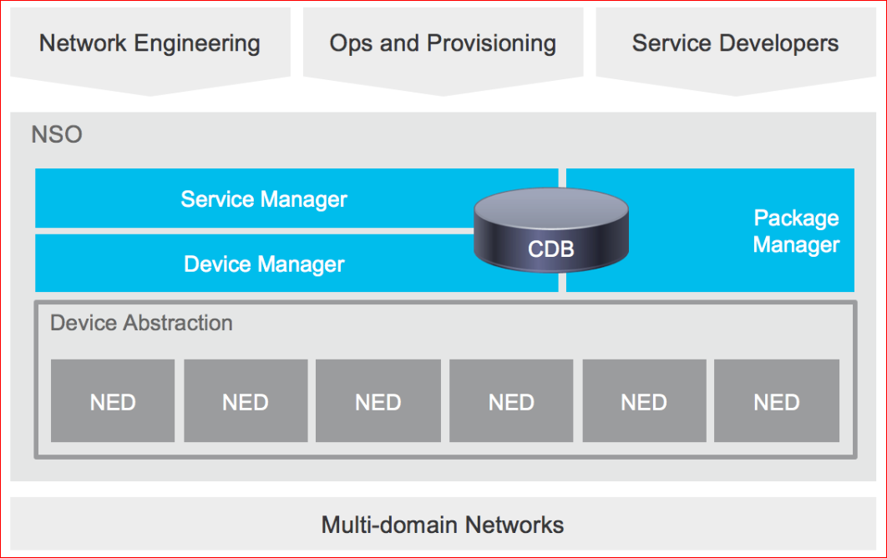

* **Core Engine:** Built on a YANG-based model-driven architecture for flexibility and scalability.
* **Device Abstraction Layer:** Provides multi-vendor abstraction to support diverse hardware and software.
* **Transaction Manager:** Manages and validates configurations to prevent network failures.
* **LSA:** addresses scalability challenges in large, distributed networks, ensuring Cisco NSO can manage complex service deployments.
* **CDB:** provides a robust and safe mechanism for managing network configurations, reducing errors and improving overall network reliability.

## **Monetization Strategy**

The **Monetization Strategy** of Cisco NSO (Network Services Orchestrator) leverages its positioning as a premium network automation and orchestration tool. Cisco focuses on several key areas to generate revenue from NSO:

* **Subscription-Based Licensing**

Ensuring a recurring revenue stream. Customers pay based on their usage and scale. E.g. $100k/year/Instance and separate cost if No. of managed devices crosses the agreed threshold.

* **Professional Services:** Cisco provides **Implementation Support by** customizing NSO for specific network environments. E.g. Sprint based development cost for NSO service package use cases, cost depend on how complex the use case is and how many sprint it will take.

Reference:  
Cisco Systems, Inc. "NSO - monetization-journey" Accessed December 29, 2024 https://blogs.cisco.com/networking/the-three-phases-of-ciscos-software-monetization-journey

## **Weaknesses**

* **Complexity**: Steep learning curve for beginners unfamiliar with YANG models, python, XML, JAVA
* **Cost**: Expensive licensing compared to some open-source alternatives.
* **Performance Bottlenecks**: May face delays in large-scale deployments with high transaction volumes if not implemented with desired Architectures.

## **Competitive Product Analysis**

|  |  |  |  |  |
| --- | --- | --- | --- | --- |
| **Aspect** | **Cisco NSO** | **Red Hat AAP (Ansible)** | **Juniper Contrail** | **Nokia NSP** |
| **Purpose** | Service orchestration and automation in multi-vendor networks. | Configuration management and task automation using playbooks. | SDN solution for network automation and policy control. | Network orchestration and service provisioning in IP/optical networks. |
| **Architecture** | Model-driven using YANG for flexibility and scalability. | Agentless, YAML-based playbooks for configuration and automation. | SDN controller-based architecture for virtual and physical networks. | Centralized control with device and service models. |
| **Vendor Support** | Strong multi-vendor support via device abstraction layer. | Multi-vendor but depends on community modules. | Primarily Juniper networks with limited vendor-agnostic support. | Vendor-specific, optimized for Nokia networks, with some third-party support. |
| **Ease of Use** | Moderate; steep learning curve for beginners. | High; simple syntax, wide adoption, and community support. | Moderate; technical expertise required for SDN policies and configurations. | Moderate; easier for Nokia-focused deployments. |
| **Key Features** | - Service lifecycle management. | - Declarative configuration management. | - Overlay networking. | - Multi-layer control. |
| - Transactional integrity. | - Event-driven automation. | - Network virtualization. | - Optical and IP integration. |
| - Rollback capabilities. |  | - Traffic policy control. | - SLA monitoring. |
| **Scalability** | High; suitable for large-scale deployments. | High; suitable for diverse and growing infrastructure. | High; focuses on SDN scalability in data centers and telcos. | High; optimized for large-scale telecom deployments. |
| **User Interface** | CLI and basic Web GUI. | Web-based dashboard with playbook management. | Advanced Web UI for SDN management. | Modern GUI for orchestration, monitoring, and analytics. |
| **Integration Options** | REST, NETCONF, and YANG-based APIs. | REST APIs and integrations with CI/CD tools. | REST APIs and SDN integrations. | Integration with Nokia OSS/BSS and third-party platforms. |
| **Automation** | Transaction-based, ensuring ACID compliance. | Task-driven, focused on idempotency. | SDN policies for automation and traffic management. | Service-driven with deep network insights. |
| **Learning Curve** | High; requires understanding of YANG models. | Low; intuitive for most IT professionals. | Moderate; knowledge of SDN and networking essential. | Moderate; requires familiarity with Nokia's ecosystem. |
| **Performance** | High, but bottlenecks possible in massive deployments without optimization. | High for general-purpose automation but limited for real-time orchestration. | High for SDN-centric use cases. | Optimized for telecom-grade network performance. |
| **Cost** | Expensive; enterprise-grade licensing. | Lower; open-source base with enterprise support options. | Expensive; tied to Juniper ecosystem. | High; designed for Nokia-centric deployments. |
| **Best Use Cases** | - Multi-vendor networks. | - IT automation. | - Data center automation. | - Telecom service provisioning. |
| - Large-scale service orchestration. | - Configuration management. | - SDN-based cloud networking. | - Optical and IP network orchestration. |
| **Competitors** | Red Hat AAP, Nokia NSP, Juniper Contrail. | Cisco NSO, Puppet, Chef. | Cisco NSO, VMware NSX. | Cisco NSO, Juniper Contrail. |
| **Strengths** | - Vendor agnostic. | - Easy to use. | - SDN focus. | - Deep integration with Nokia devices. |
| - Model-driven flexibility. | - Large community. | - Excellent for overlay networking. | - Advanced analytics and SLA monitoring. |
| - Robust customized package automation. | - Task automation for diverse needs. |  |  |
| **Weaknesses** | - High cost. | - Limited real-time orchestration. | - Limited vendor support outside Juniper. | - Limited third-party support. |
| - Complex for new users. | - Community modules vary in quality. | - High cost for full feature set. | - Vendor lock-in with Nokia systems. |

## **Potential Use Cases**

## Broadband Blitz – Faster, Simpler: The Future of Broadband Provisioning

## Broadband Blitz Auto Speed Booster – Festival Speed Upgrades Made Simple – Automated, CRM-Driven, and On-Demand

## Insta-Secure Broadband Activation – One Click to a Safer Internet – Simplified PCRF Security

## Firewall Policy Provisioner – Set it and forget it. Firewall Policy Provisioner does the heavy lifting

## Broadband_Pause – Effortless Broadband Control at Your Fingertips

## L3VPN Autopilot – The Future of L3VPN Management.

## Netreveal-OnDemand Network Device Reporter

## Port management Suite: Streamlining Network Management: Lookup, Clean, Reserve

## BGP Traffic Manager – Intelligent Traffic Steering for Optimal BGP Performance

## BGP Link Maestro – Effortless BGP Link Control

## **References:**

Cisco Systems, Inc. "Cisco Crosswork Network Services Orchestrator (NSO)." Accessed December 28, 2024. <https://www.cisco.com/site/us/en/products/networking/software/crosswork-network-services-orchestrator/index.html>

Cisco Systems, Inc. "Network Services Orchestrator (NSO) Documentation and Downloads." Accessed December 28, 2024. <https://developer.cisco.com/docs/nso/>

Cisco Systems, Inc. "Cisco Network Services Orchestrator (NSO): The Bridge to Automation." Accessed December 28, 2024. <https://www.cisco.com/c/en/us/solutions/service-provider/solutions-cloud-providers/network-services-orchestrator-solutions/bridge-to-automation.html>.

Cisco Systems, Inc. "Cisco Network Services Orchestrator At a Glance." Accessed December 28, 2024. <https://www.cisco.com/c/en/us/products/collateral/cloud-systems-management/network-services-orchestrator/at-a-glance-c45-734640.html>.

Cisco Systems, Inc. "Cisco Crosswork Network Services Orchestrator Data Sheet." Accessed December 28, 2024. <https://www.cisco.com/c/en/us/products/collateral/cloud-systems-management/network-services-orchestrator/datasheet-c78-734576.html>.

Cisco Systems, Inc. "Cisco Network Services Orchestrator for Small and Midsize Service Providers." Accessed December 28, 2024. <https://www.cisco.com/c/en/us/products/collateral/cloud-systems-management/network-services-orchestrator/at-a-glance-c45-744442.html>.

Cisco Systems, Inc. "Segmentation Strategy - Cisco Community." Accessed December 28, 2024. <https://community.cisco.com/t5/security-knowledge-base/segmentation-strategy/ta-p/3757424>.

Cisco Systems, Inc. "Applications in NSO - Network Services Orchestrator (NSO) v6.3." Accessed December 28, 2024. <https://developer.cisco.com/docs/nso/guides/applications-in-nso/>.

Cisco Systems, Inc. "NSO - Network Services Orchestrator - Cisco DevNet." Accessed December 28, 2024. <https://developer.cisco.com/site/nso/>.

Cisco Systems, Inc. "NSO Expert Insights Series: Foundation to mastering NSO." Accessed December 28, 2024. <https://community.cisco.com/t5/service-providers-knowledge-base/nso-expert-insights-series-foundation-to-mastering-nso/ta-p/5228227>.

Cisco Systems, Inc. "Customer Stories - Cisco Video Portal." Accessed December 28, 2024. <https://video.cisco.com/category/videos/customer-stories>

Cisco Systems, Inc. "NSO - Network Services Orchestrator - Cisco DevNet Videos." Accessed December 28, 2024. <https://developer.cisco.com/site/nso/video/>

Cisco Systems, Inc. "Network Services Orchestrator (NSO) 6.0 Feature Overview." Accessed December 28, 2024. <https://www.youtube.com/watch?v=Zgu5u9SrQ2A>

Cisco Systems, Inc. "Cisco CPSG NSO Overview and Automating Operations." Accessed December 28, 2024. <https://www.youtube.com/watch?v=R7QHd7l2lsw>

Packet Pushers. "Getting to Know Cisco's Network Service Orchestrator (NSO)." Accessed December 28, 2024. <https://www.youtube.com/watch?v=oIpcHW_srR4>